Project Planning Phase
Project Planning Template (Product Backlog, Sprint Planning, Stories, Story points)

Date | 15 February 2025
Team ID | LTVIP2026TMIDS68930
Project Name | Asset Management Portal
Maximum Marks | 5 Marks

Product Backlog, Sprint Schedule, and Estimation (4 Marks)
Use the below template to create product backlog and sprint schedule
Sprint | Functional  Requirement (Epic) | User Story  Number | User Story / Task | Story Points | Priority | Team  Members
Sprint-1 | Registration | USN-1 | As a user, I can register for the application by entering my email, password, and confirming my password. | 2 | High | Dev-1
Sprint-1 | Registration | USN-2 | As a user, I will receive confirmation email once  I have registered for the application | 1 | High | Dev-2
Sprint-2 | Registration | USN-3 | As a user, I can register for the application through Facebook | 2 | Low | Dev-1
Sprint-1 | Registration | USN-4 | As a user, I can register for the application through Gmail | 2 | Medium | Dev-2
Sprint-1 | Login | USN-5 | As a user, I can log into the application by entering email & password | 1 | High | Dev-1
Sprint-2 | Dashboard | USN-6 | View user dashboard after login | 3 | High | Dev-2
Sprint-3 | Dashboard | USN-7 | Display user profile information | 2 | Medium | Dev-1
Sprint | Functional  Requirement (Epic) | User Story  Number | User Story / Task | Story Points | Priority | Team  Members
Sprint-4 | Dashboard | USN-8 | Logout functionality | 1 | Low | Dev-2

Project Tracker, Velocity & Burndown Chart: (4 Marks)
Sprint | Total Story  Points | Duration | Sprint Start Date | Sprint End Date  (Planned) | Story Points  Completed (as on  Planned End Date) | Sprint Release Date  (Actual)
Sprint-1 | 20 | 6 Days | 24 Oct 2022 | 29 Oct 2022 | 20 | 29 Oct 2022
Sprint-2 | 20 | 6 Days | 31 Oct 2022 | 05 Nov 2022 | 18 | 06 Nov 2022
Sprint-3 | 20 | 6 Days | 07 Nov 2022 | 12 Nov 2022 | 20 | 12 Nov 2022
Sprint-4 | 20 | 6 Days | 14 Nov 2022 | 19 Nov 2022 | 19 | 20 Nov 2022
Sprint-5 | 20 | 6 Days | 21 Nov 2022 | 26 Nov 2022 | 20 | 26 Nov 2022
Sprint-6 | 20 | 6 Days | 28 Nov 2022 | 03 Dec 2022 | 17 | 04 Dec 2022
Sprint-7 | 20 | 6 Days | 05 Dec 2022 | 10 Dec 2022 | 20 | 10 Dec 2022
Sprint-8 | 20 | 6 Days | 12 Dec 2022 | 17 Dec 2022 | 19 | 18 Dec 2022

Velocity:
Imagine we have a 10-day sprint duration, and the velocity of the team is 20 (points per sprint). Let’s calculate the team’s average velocity (AV) per iteration unit (story points per day)
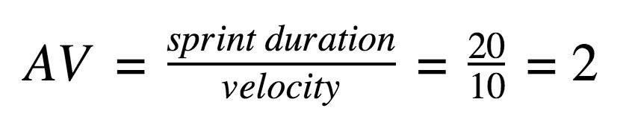

Burndown Chart:
A burn down chart is a graphical representation of work left to do versus time. It is often used in agile software development methodologies such as Scrum. However, burn down charts can be applied to any project containing measurable progress over time.


https://www.visu
a

l

-

p
aradigm.com/scrum/scr
u

m

-

w
urndo
b

n

-

c
har
t

/

w
https://www.atlassian.com/agile/tutorials/burndo

n

-

c
har
t

s

Reference:



